SDLC MODELS

1. **WATER FALL MODEL**

* Winston Royce introduced the waterfall model in 1970.
* It is a first SDLC model.
* It is classical model.
* To create system with linear and sequential approach.
* It is termed a waterfall. Because the model develops systematically from one phase to another phase in a downward fashion.
* Each phase must be completed before the next phase can begin. The output of one phase will be input of next phase.
* Requirements are not changed.

ADVANTAGE

* Workers well for smaller projects.
* Results are well documented.

DISADVANTAGE

* Errors can be fixed only during the phase.
* No feedback path in customer.
* It does not allow to go back.

Eg:

Calculator, school registration, government and defence project etc

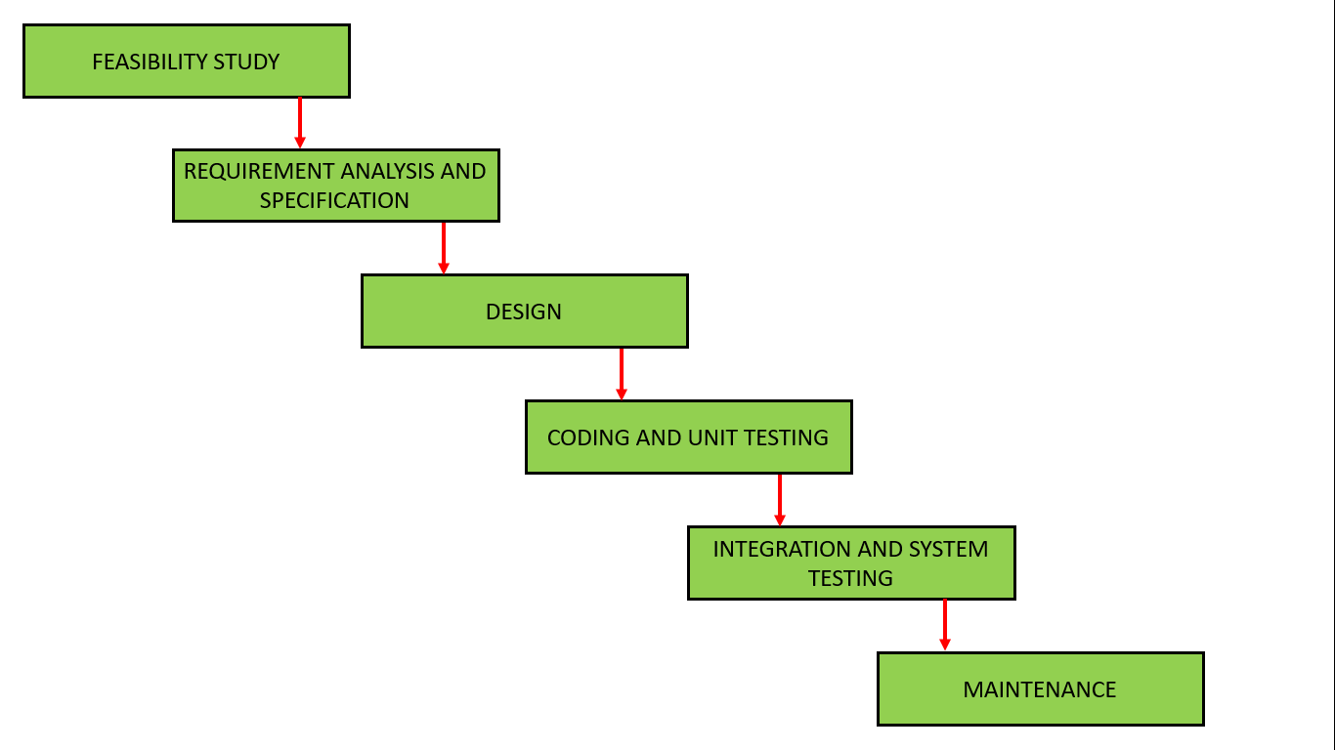

1. **V MODEL**

* It is extension of water fall model
* It is also known as VERIFICATION or VALIDATION MODEL.
* V MODEL is a highly disciplined SDLC model
* That has a testing phase parallel to each development phase.
* The entire figure looks like a V hence the name V MODEL.

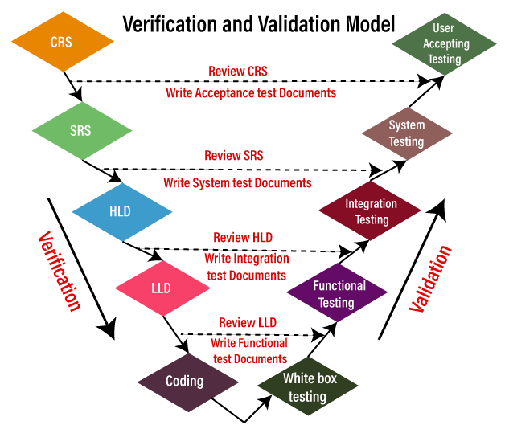

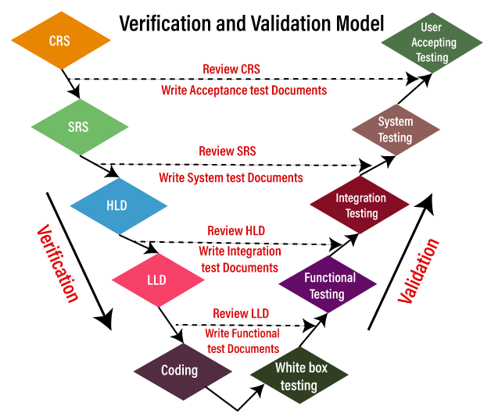

Testing are done by each stage.

Verification = SDLC

Validation= STLC

SDLC conduct white box & black box.

The next phase starts only after completion of the previous phase

ADVANTAGE

* Used for a small projects
* Clear and structured process

DISADVANTAGE

* Time consuming.
* High risk and uncertainty.

VERIFICATION

* It includes checking documents, design, coding, programs.
* Static testing
* It does not include the execution of the code
* Methods are review, walkthrough, inspection.
* Prevention of errors.
* It is objective process.
* Done by developers.

VALIDATION

* It includes testing and validating actual product.
* Dynamic testing
* It includes execution of codes
* Methods are black box , white box ,nonfunctional.
* It is subjective process.
* Done by testers

EG: SRS TO GMAIL APPLICATION

|  |  |
| --- | --- |
| 1. | **Login** ( module) |
| 1.1 | User name→ Text box (functional specification ) |
| 1.1.1 | User name→ Accept only 5 alphabets |
| 1.2 | Password→ text box |
| 1.2.1 | Password→ Accept only 8 characters, in which one should be capital and one special character(@,$,%,&) |
| 1.3 | OK→ Button |
| 1.3.1 | OK→ enabled |
| 2. | **Compose** |
| 2.1 | To→ Text Box |
|  | ----- |
|  | ----- |
| 3. | **Inbox** |
| 3.1 | ---- |
|  | ---- |
| 4. | **Logout** |

**3 ITERATIVE MODEL**

* This is the software development process in iteration.
* The process of development in a cycle manner. Repeating every step after every cycle of SDLC process.
* On every next iteration, more feature ,modules are designed, coded, tested and added to the software.

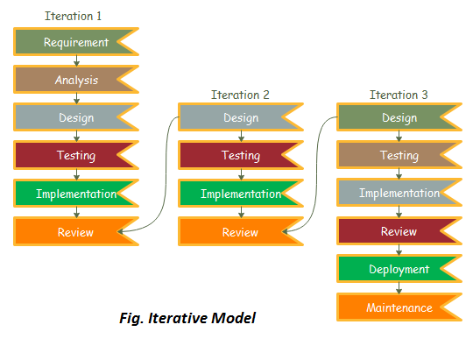

* Start with some of the software specifications and develop the first version of the software.
* After the first version if there is a need to change the software, then a new version of the software is created with a new iteration.
* Every release of the Iterative Model finishes in an exact and fixed period that is called iteration.
* EG: Microsoft has released multiple versions of the Windows operating system to add functionality for users and to correct bugs. Each different version is a different iteration of its operating system and the goal is for the next iteration to be better than the last.

ADVANTAGE

* It creates high level design of the application.
* Limited time spend on documentation and extra time on designing
* Testing and debugging during smaller iteration is easy.

DISADVANTAGE

* It is suitable for smaller project.
* Design can changed again and again .
* Imperfect requirements.

**4.AGILE MODEL**

**\*** It is mostly used model in todays.

* Now each and every software are used in agile model.

Eg: Instagram, whatsapp, facebook etc…

* It follows incremental and iterative process of software development.
* Traditional vs agile model working with examples
* Here we used Instagram application.
* Requirements are :

1) Follow –unfollow

2) Edit profile

3) Search

4) Messaging

5) Post photos

6) Upload story

7) To make reels

8) Go live

Working of AGILE

Iteration 1:

* To collect all the requirements from the customer
* They give highest priority in some requirements.
* Suppose they want 1,2,3 requirements are first.
* So agile model develops 3 requirements first.
* Design- develop-test-deploy.
* Then the result gives to the customer.
* Customer gave the review for this requirements development.
* If the customer wants to any change.
* Then we go to the next iteration.

Iteration 2:

* They make the changes as per the customer requirement and they develop next iteration 4,5,6 and they continue the process.
* finally getting the deploy.
* Then they after again the customer feedback.
* If they want any change then it go the next iteration.

Iteration 3:

* They solve those changes and they develop another 7,8 requirements development.
* At the all requirement are full filled.
* Then they deploy to the customer and again take the customer review. if the customer want to change they solve all changes and lauch the product.
* AGILE MODEL divide the complete requirements into multiple iterations and they develop the product as their priority requirements.

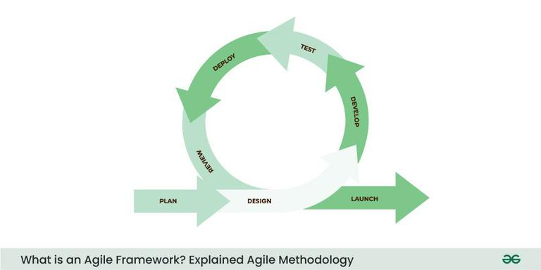

* Agile model use 2 policies

1. Scrum

2. Kanban

Scrum

* It is a process in agile.
* To collaborate working manner with all other to team , dev , QA , customers , business.
* Typically scrum schedule in 2-4 weeks.

Product Owner

* Prioritizing the product backlog
* Person ensuring that the team delivers value to the business.
* Person responsible for defining the features of the product.

Scrum Master

* A facilitator coachs the team.

Dev team

* The group of professionals responsible for delivering the product increments.
* It includes developers, testers and other specialists.

Product Backlog

* A prioritized list of all the features.

Sprint

* A time boxed iteration during which a potentially shippable are usually 2 to 4 weeks long.

Sprint Planning

* A meeting at the beginning of each sprint where the team selects item from the product backlog to work on during the sprint.

Daily Scrum

* A short daily meeting where team members discuss their progress, plans for the day.

Sprint Review

* A meeting at the end of the sprint where the team demonstrates the work completed during the sprint and gathers feedback from the stake holders.

Sprint Retrospective

* A meeting at the end of the sprint where the team reflects on their performance and identities opportunities for the improvement in the next sprint.

Scrum Events

* The predefined time boxed events in scrum including sprint planning, daily standup, sprint review and sprint retrospective.

ADVANTAGE

1. The customers are satisfied because after every Sprint working feature of the software is delivered to them.
2. Changes in the requirements are accepted even in the later stages of the development.

DISADVANTAGE

1. In Agile methodology the documentation is less.

2.Sometimes in Agile methodology the requirement is not very clear hence

3. it’s difficult to predict the expected result.